Assessment outline:



**Macroeconomics**

* Studies the **aggregate impact** of individual decisions.
* “Good” Economic Performance:

1. Rising living standards

* Life expectancy
* Healthcare
* Education
* Infant mortality

1. “Smoothing” business cycle
2. Maintain the real value of the currency

* Inflation (alters the purchasing power of a dollar)

1. Sustainable levels of debt
2. Balanced spending vs saving
3. Full-employment

**GNP**

* Gross national product
* Market value of the final goods and services produced by a country during a given period

**GDP**

* Gross domestic product
* GDP Identity:

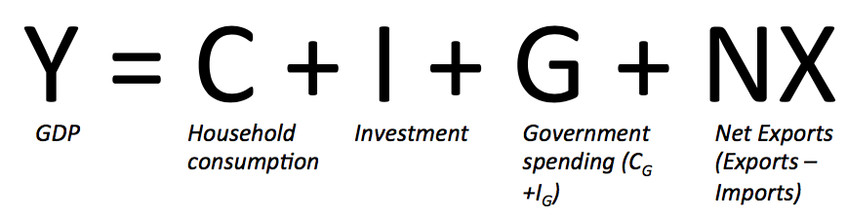

* 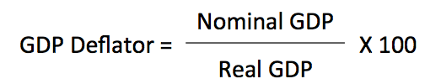
* Market value of the final goods and services produced in a country during a given period
* Short-run fluctuation --- business
* Long-run growth --- better living standard (eg. Higher female participation in the labour force has made a significant contribution to GDP growth over the 20th century)
* Can be calculated using

1. Production method: Add up the value added (revenue-costs) by each firm along the

production chain

1. Expenditure method: Add up everything spent by final consumers in the economy (Domestic production by households, all firms, government and foreigners)
2. Income method: Traces who earns the income from the sale of all goods and services in the economy. (GDP = labour income (wages, salaries, self-employed income) + capital income (payments to physical capital, intangible capital and profits))

* Difficult to measure due to

1. Price change
2. Multi-stage production
3. Multinational production
4. Informal economy + public goods

* Advantages:

1. Relatively easier to measure
2. Correlated with living standards & life expectancy & happiness

* Disadvantages:

1. Excludes the quality of life
2. Excludes poverty and economic inequality
3. Excludes environmental quality and resource depletion

**Nominal GDP**

* Market value at current prices of the final goods and services produced in a country during a given period
* Nominal GDP = Real GDP × GDP Deflator
* The difference in the growth of nominal GDP and Real GDP is due to inflation

**Real GDP**

* Market value at constant prices of the final goods and services, which are calculated using a fixed reference year (base year).
* Rises when quantities rise or when higher valued items are being produced. (which is also complicated because the things produced and consumed vary between years)

**Consumer Price Index (CPI)**

* 
* Price of the basket of goods consumed by Australian households (ie. Produced in Australia and aboard) in a given year, relative to the cost of that basket in a base year
* Measures average cost of living --- more of a focus for policymakers
* It is used to calculate the rate of inflation
* Includes foreign-produced components (eg. Imported hamburger)

**Inflation**

* 
* It is the percentage change in the CPI over the specified time period.
* Inflation is an average measure --- some prices rise and others fall then inflation may be 0
* “Headline inflation” includes food and energy prices, while “Core inflation” excludes them.
* Adjusting for inflation makes prices comparable over time, with reference to the average cost of living ---- to give a better idea of what those wages can buy.
* Can be difficult to measure, because:

1. Quality adjustment bias: inflation can be overstated because quality improvements over time in goods and services are difficult to adjust for. (eg. IPhone vs Nokia)
2. Substitution bias: The basket of goods and services is fixed, but higher prices in one good leads consumers to substitute cheaper goods.

* Some inflation is helpful:

1. Help adjust relative prices
2. Allows steady, stable economic growth
3. Let the government to collect “seignorage tax”: printing money to finance spending, causing inflation which devalues existing currency

* But high inflation can be very costly:

1. Distorts relative prices: if some prices change faster than others
2. Distorts taxation: “tax bracket creep” ---- a movement into a higher tax bracket as nominal wages increases
3. Introduces noise --- firms don’t know whether high prices are due to demand or inflation
4. Redistribute wealth: borrowers benefit at expense of savers. Encourage speculation
5. Creates shoe-leather costs: consumer hold less cash on hand
6. Creates menu costs: expensive to continually change listed prices

* Link to interest rate by the Fisher equation

**Deflation**

* Deflation is when the average price level (CPI) falls (π < 0) --- typically due to slowing aggregate demand.
* Nominal interest rate must be i > 0 (The “Zero Lower Bound (ZLB)”) --- otherwise should just hide cash under the pillow
* If deflations happens at the ZLB there can be a spiral, as it will cause real interest rate to fall, discouraging investment.

**Interest Rates**

* Link to inflation by the Fisher equation

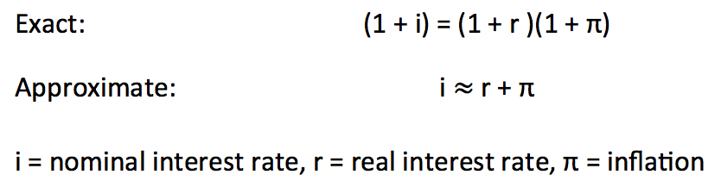

Nominal interest rate = Real interest rate + Inflation

* Inflation directly affects nominal interest rate
* Inflation may also directly affect nominal interest rate because the Reserve Bank of Australia (RBA) will change the real interest rate to slow inflation
* The real interest rate reflects the true cost of borrowing, it is the compensation someone earns from lending money (or delaying consumption from today to tomorrow)
* Fore a given real interest rate, high inflation reduces the real interest rate. This redistributes wealth from lenders to borrowers.

Questions:

* 1.1 What does gross domestic product (GDP) mean?
* 1.2 What are the three ways of measuring a country’s GDP?
* 1.3 What is the distinction between nominal and real GDP?
* 1.4 What does the consumer price index (CPI) mean?
* 1.5 How is the CPI measured?
* 1.6 What is inflation and how is it measured?
* 1.7 What are the economic costs associated with inflation?
* 1.8 What is the relationship between rates of interest and the rate of inflation?
* 1.9 What is deflation and why is it regarded as a problem?